

INT 332 – DevOps Virtualization and Configuration Management

Name : GUDA SAGAR
Section : KO021
Reg No : 12218728
Roll No : KO021A26

DevOps CI/CD Pipeline Implementation
Using Docker, Docker Swarm, AWS, React, Nodejs, Full Stack Application

Submitted To – Submitted By – Ritika Mahajan
1. Abstract
This project demonstrates the end-to-end implementation of a DevOps CI/CD pipeline for a full-stack web application named Pro-Vertos. The frontend is built using React with Vite, and the backend is built on Node.js using the Express framework. MongoDB is used as the database. The application is containerized using Docker and deployed through Docker Swarm on an AWS EC2 instance. Jenkins automates the pipeline using a GitHub webhook, making the delivery process seamless and reliable.
This pipeline ensures that every time code is pushed to GitHub, Jenkins automatically pulls it, builds Docker images, pushes them to Docker Hub, and deploys the updated containers on the Swarm cluster. This CI/CD workflow not only increases developer productivity but also ensures consistency, scalability, and fast delivery across environments.

2. Introduction
In modern development environments, speed and reliability are critical. DevOps enables faster delivery, improved quality, and better collaboration between development and operations. Pro-Vertos is a real-world MERN stack web app that empowers students and event organizers to manage, register, and collaborate on events. This report outlines the implementation of a DevOps pipeline for Pro-Vertos to automate code integration, testing, and deployment using industry-standard tools.

3. Tools & Technologies Used
Docker: Containerized the backend (Node.js/Express) and frontend (React/Vite).
Docker Swarm: Orchestrated multi-container deployments on AWS.
AWS EC2: Hosted Jenkins and served as Swarm manager node.
Jenkins: Automated the pipeline from GitHub code pull to deployment.
GitHub: Used for version control and triggered builds via webhook.
MongoDB: NoSQL database used to store user, event, and registration data.
Node.js + Express: Backend REST API for user auth, event management, and data operations.
React + Vite: Fast, optimized frontend with modular architecture.
Nginx: Used to serve the frontend build artifacts.

4. Architecture Diagram (Textual Representation)
Flow:
Developer pushes code to GitHub
GitHub webhook triggers Jenkins on AWS EC2
Jenkins pulls code, builds backend & frontend
Docker builds images and pushes them to Docker Hub
Docker Swarm pulls images and deploys containers on EC2
App becomes accessible via EC2 Public IP

5. CI/CD Workflow
Continuous Integration (CI):
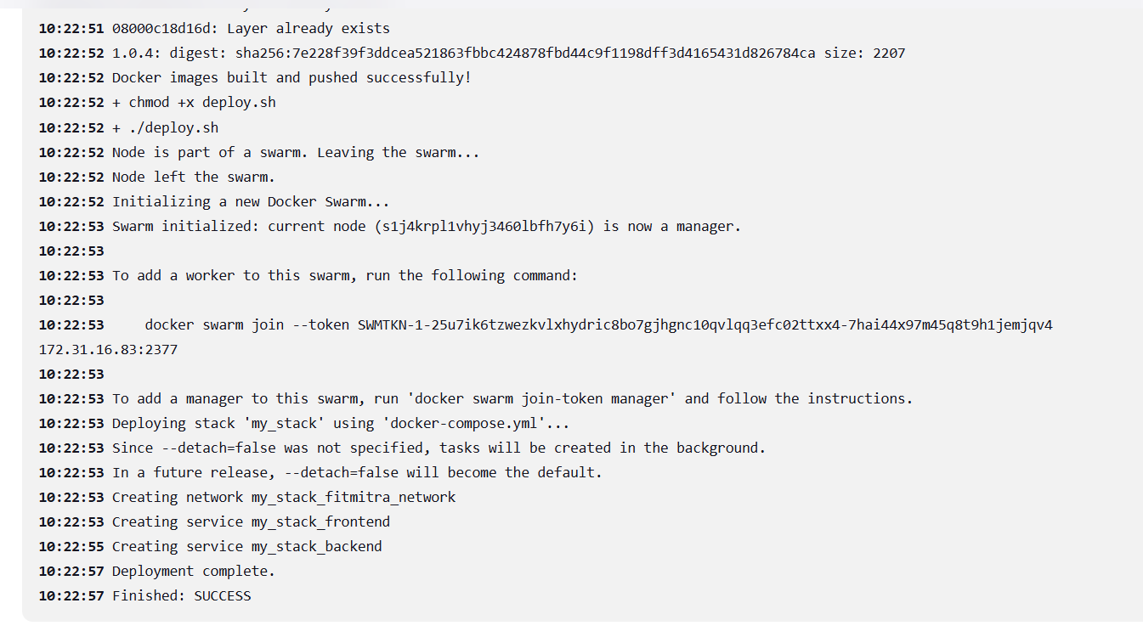
GitHub webhook triggers Jenkins build on push
Backend (Node.js) and frontend (React/Vite) are built
Docker images created using custom Dockerfiles
Images pushed to Docker Hub

Continuous Deployment (CD):
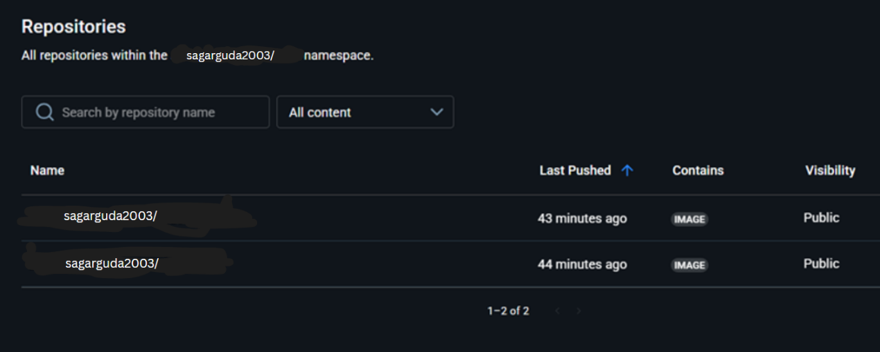
Docker Swarm pulls latest images from Docker Hub
Services are redeployed using docker stack deploy
Containers start with updated code
EC2 public IP provides access to live application

6. Docker & Docker Swarm
Backend Dockerfile:
Uses node:18-alpine as base image
Installs dependencies and starts Express server on port 4000
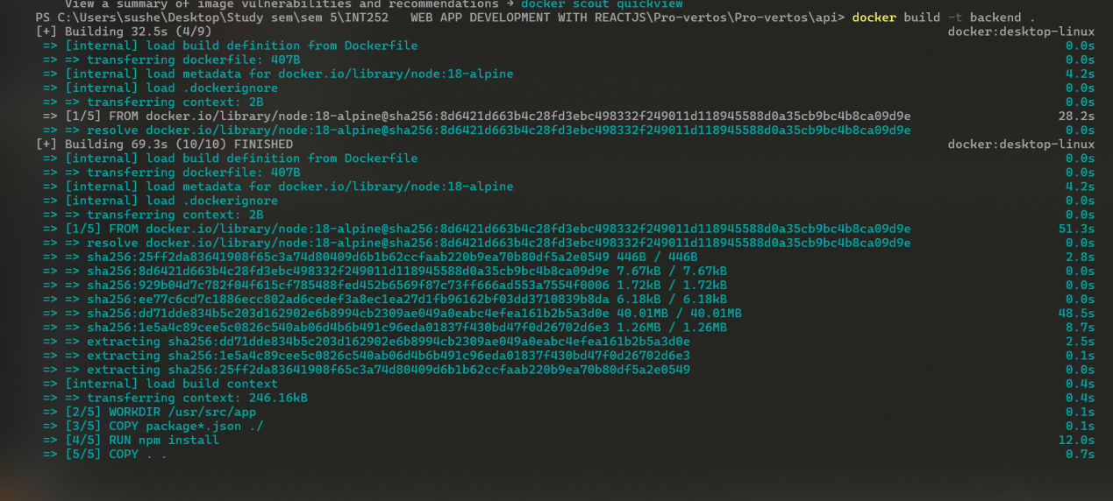
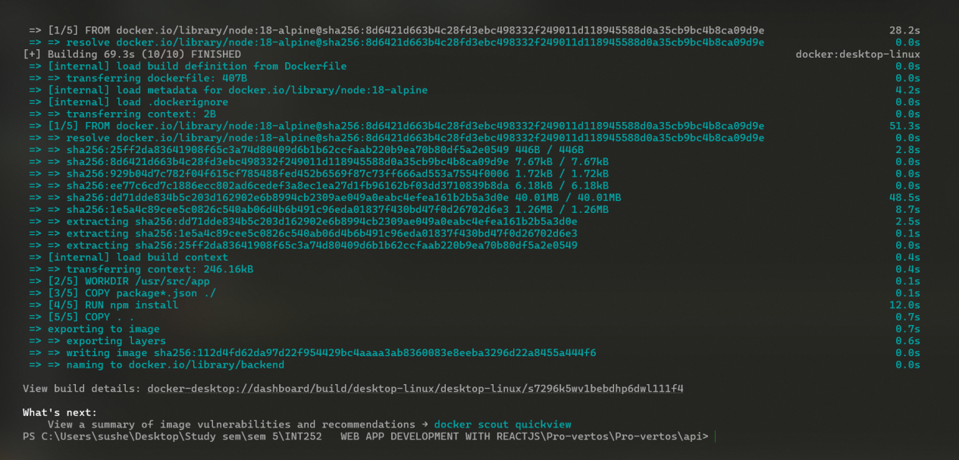

Frontend Dockerfile:
Uses node:18-alpine to build Vite project
Then uses nginx:alpine to serve the dist folder

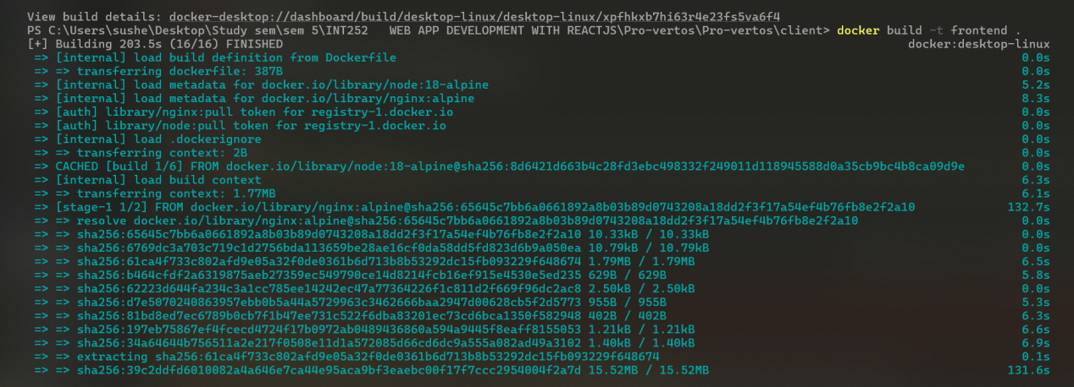
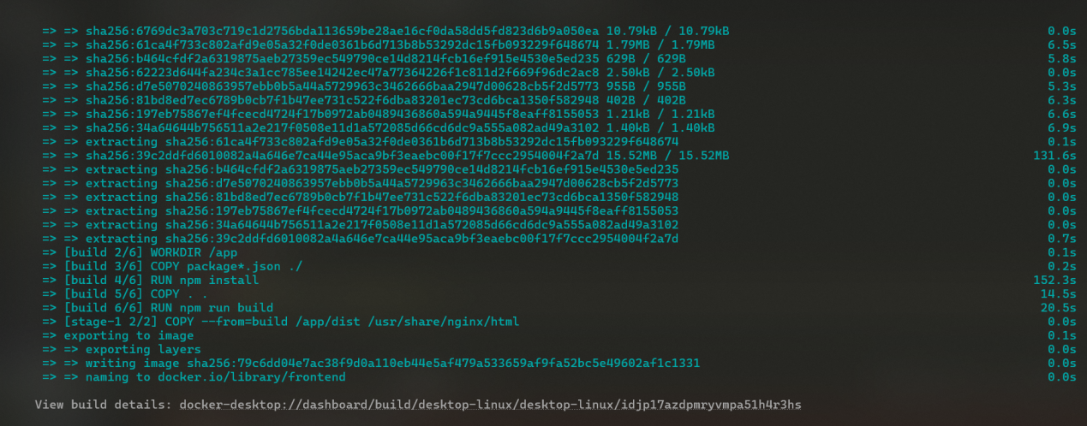

API backend Dockerfile
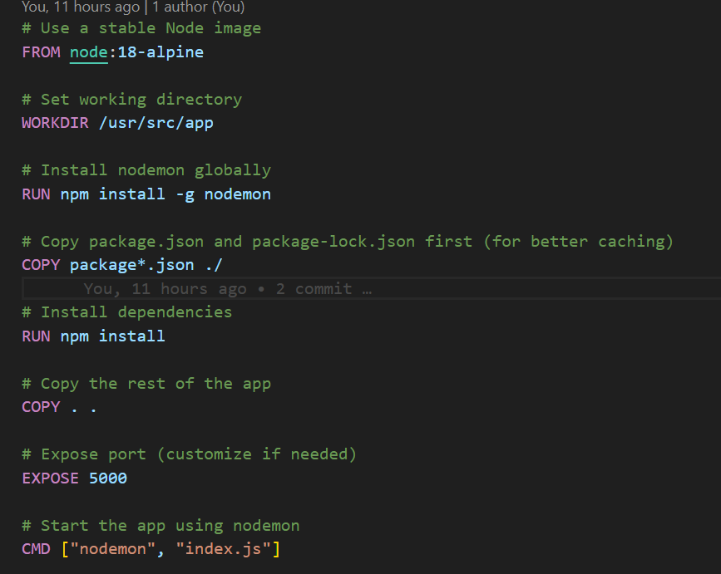
Client frontend Dockerfile
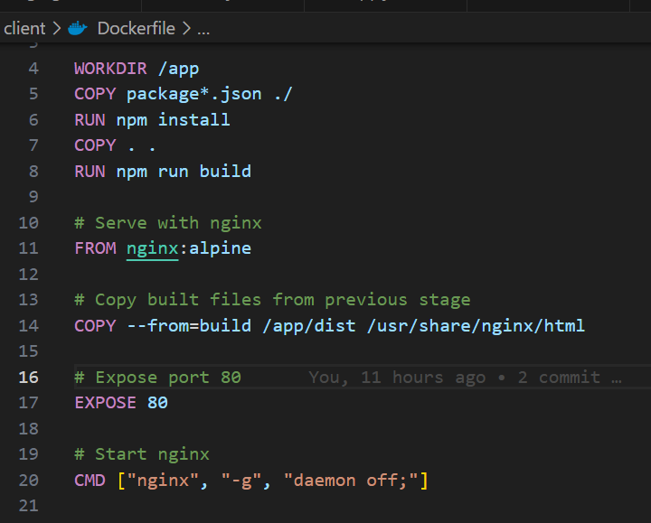

Docker Compose File:
version: '3.8'
services:
frontend:
image: sagar/healthdata-frontend
deploy:
replicas: 3
resources:
limits:
cpus: '0.5'
memory: 500M
ports:
- "80:80"
networks:
- healthdata_network

backend:
image: sagar/healthdata-backend
deploy:
replicas: 2
resources:
limits:
cpus: '1'
memory: 1G
ports:
- "4000:4000"
environment:
- MONGO_URL=mongodb+srv://<username>:<password>@cluster0.mongodb.net/healthdata
networks:
- healthdata_network

networks:
healthdata_network:
driver: overlay

Docker Swarm Deployment

docker swarm init # On EC2 manager node
docker stack deploy -c docker-compose.yml healthdata_stack
Defines services for frontend and backend
Exposes ports 80 and 4000
Uses prebuilt Docker images
Docker Swarm Setup:
docker swarm init on EC2 manager node
docker swarm join on worker nodes (if any)
Deployment via docker stack deploy -c docker-compose.yml fitmitra_stack

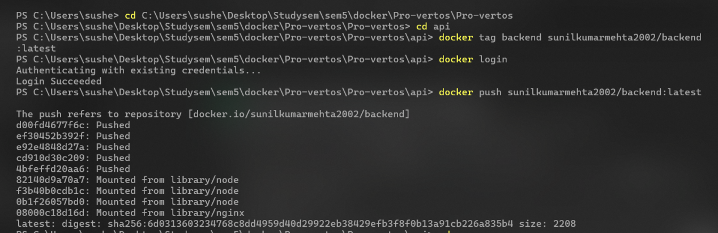
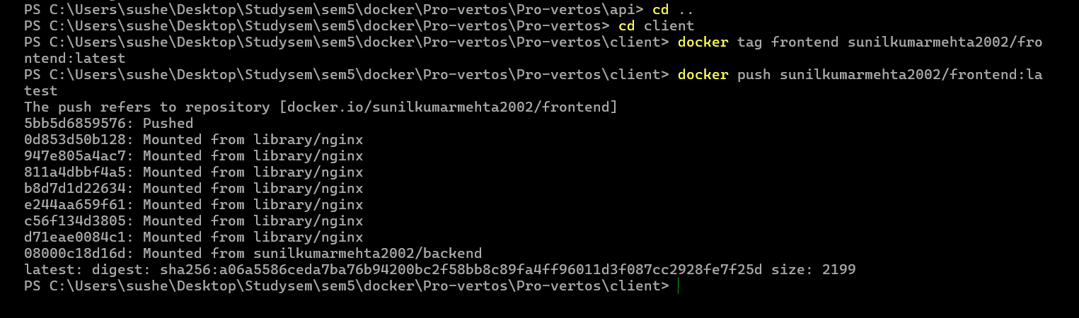
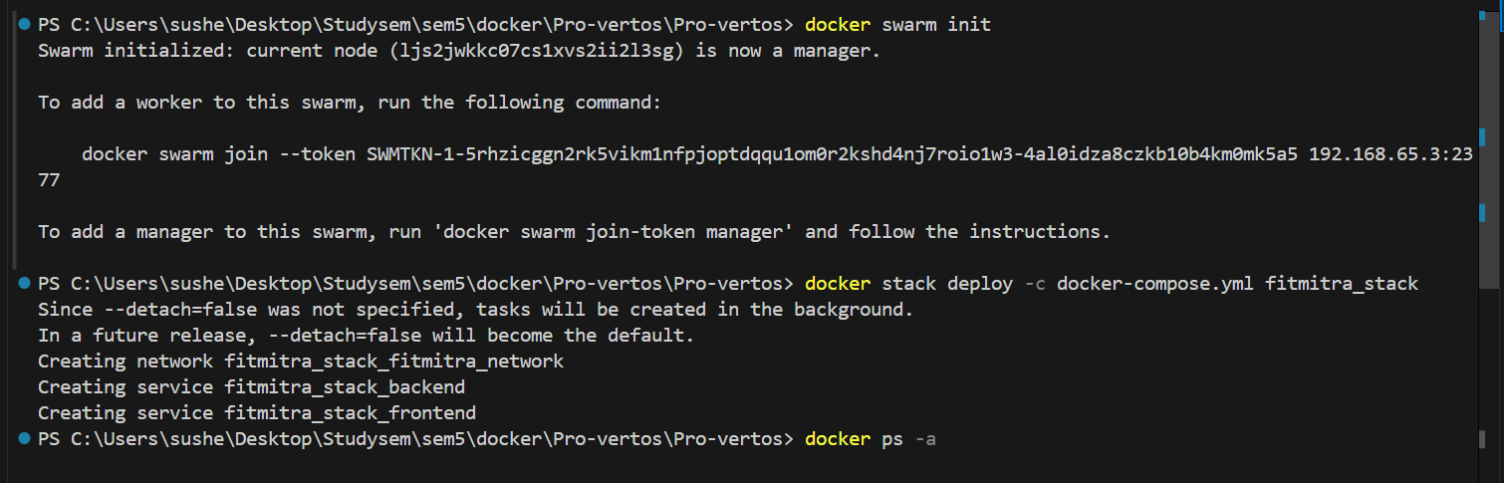

7. AWS Deployment
AWS EC2 Ubuntu instance created
Docker & Jenkins installed manually
Security groups opened for ports 22 (SSH), 80 (frontend), 4000 (backend), and 8080 (Jenkins)
Jenkins job builds the app, pushes Docker images to Docker Hub, and redeploys containers on Swarm
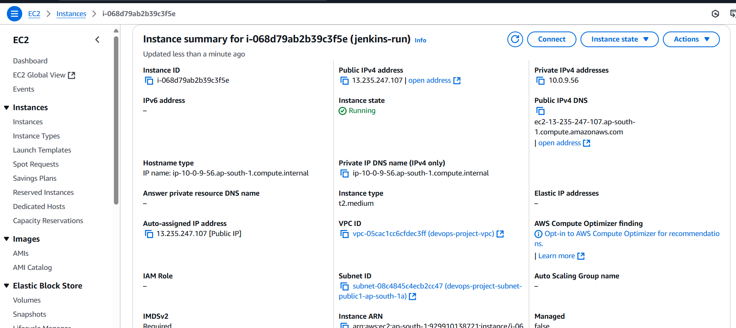

8. Challenges Faced
Dockerfile errors due to wrong paths during Vite build
MongoDB connection issues during container startup
Port conflicts during local testing
Jenkins permission issues on EC2
Docker image size large initially, optimized using multi-stage builds

9. Results / Output
App deployed successfully on AWS EC2
Accessible via EC2 Public IP: frontend on port 80, backend API on 4000
GitHub webhook triggers Jenkins on every push
Jenkins console logs confirm CI/CD stages
Docker containers run stably in Swarm
GitHub Repo: Sunilkumarmehta2002/docker-project
10. Conclusion
This project successfully implemented a production-level CI/CD pipeline for a MERN stack web app. The integration of Docker, Jenkins, and AWS allowed for smooth, automated deployment and scaling. Going forward, monitoring tools like Prometheus and centralized logging (ELK) can be added to enhance observability and reliability.
11. References
Docker Docs: https://docs.docker.com/
Jenkins Docs: https://www.jenkins.io/doc/
AWS EC2: https://aws.amazon.com/ec2/
MongoDB Docs: https://www.mongodb.com/docs/
Vite + React: https://vitejs.dev/
Node.js: https://nodejs.org/
Nginx Docs: https://nginx.org/en/docs/

